Attica Independent Fair entry process using FairEntry online registration.

* Open Registration starts Sunday June 1st 2025
* Entry Deadline due on Thursday June 15th 2025

All Attica fair junior fair exhibitors (4h and FFA) must complete their junior fair entries online. We ask that you please read the entire guide before attempting to make your entries to ensure you have all required information and documentation available.

**Important**

* For EVERY project you plan to bring to this year’s fair. You must make an entry using our FairEntry online registration. This includes livestock, showmanship, still projects, poster contest and clover buds.
* To submit entries, you must click “Continue to payment”, all invoices will be $0.00.
* After submitting entries, you will receive an initial confirmation email detailing what you submitted. If you do not receive this email, check your junk or spam box. Once your entries have been reviewed by our FairEntry staff you will receive a second email with information on the acceptance or rejection of your entries. Allow up to 3 days to receive the acceptance/rejection email. Again, check junk or spam box if you do not receive the confirmation email. Rejected entries must be fixed and resubmitted by the July 15th deadline.
* If your entries have been submitted but not yet approved or rejected you will not be able to add or edit entries. Once entries have been approved or rejected you will be able to log back in to make corrections or add entries.
* Questions- email atticajrfair@gmail.com or call/text 419-681-3472

**Please have the following available before starting entries**

**All Entries:**

* Family 4HOnline username and password.
* FFA members will create a FairEntry account. You may already have a FairEntry account if you were in FFA or 4H last year.

**Livestock Entries:**

* You will need to enter animal info for each animal you plan to bring.
* Pens of 2 or 3 animals (rabbits and poultry) will need only one entry for the pen.
* If you plan to bring more than one animal or more than one pen of animals for a particular project you will need to make more than one entry. (ex. 2 beef steers or 2 market rabbit pens of three)
* Information will vary by animal type. See chart at end of document.
* Animal info can be changed at check-in if you decide to bring a different tagged animal.

**Showmanship Entry**

* You **MUST** make a showmanship entry into the appropriate age group for each species you show.
* Beef and goat exhibitors may need to enter more than one showmanship class depending on what you show

**Detailed Instructions**

 ***Do not Continue to Payment or Submit until all entries for all members of your family have been made***

 1. Go to our custom FairEntry URL <http://atticafair.fairentry.com>

 2. Sign in

* 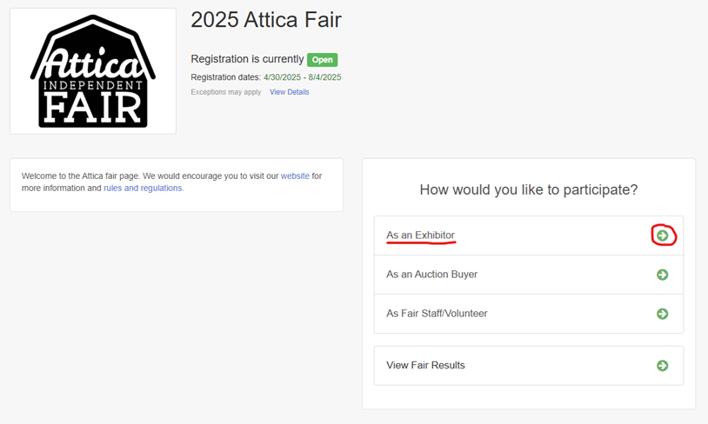Home screen appears, select “As An Exhibitor”
* **4-H families** sign in using your 4HOnline family account.
* 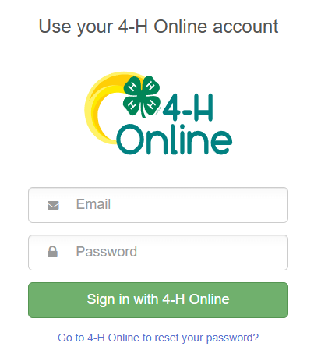**FFA members with a sibling** in 4-H sign in using the family 4HOnline account and select or register the FFA member.
* **Exhibitors in both 4-H and FFA** sign in using the family 4HOnline account. You will be able to select the proper club or chapter for each entry. Some glitches may occur for dual enrollees. Email us if you have any problems.
* **FFA members with no 4-H siblings** will use last year's FairEntry account or click the link to create a FairEntry Exhibitor account.

 3. Click-**Begin Registration**- then **Exhibitors**- then **Individual**

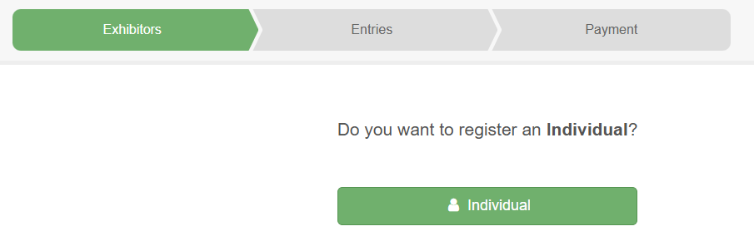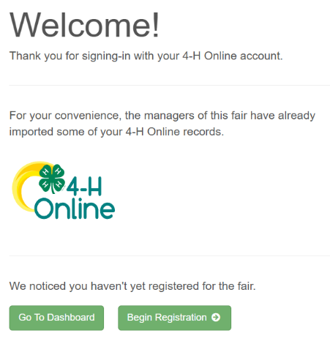

 4. Select an exhibitor or click “Register an Exhibitor” for FFA members not listed and click Continue.

5. Go to **Entries** Tab, then select the **“+ Add an Entry”** box.

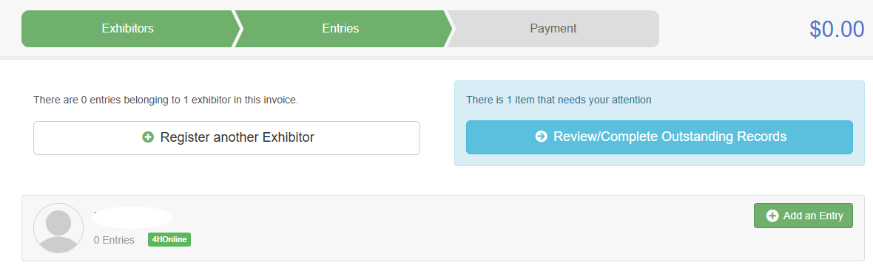

   5.  Choose Department and Division

* Select a department, select a division, click **Choose**.
* 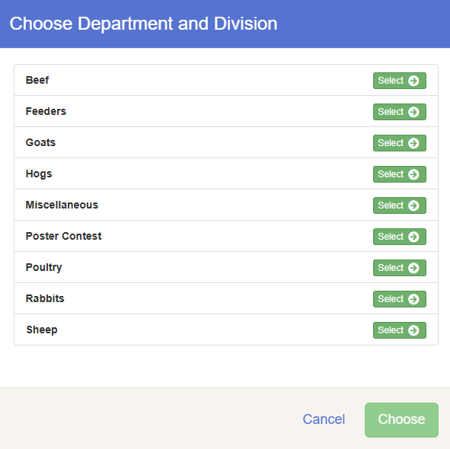Select a Class to continue, click **Continue**.

- Note: There are blue **Change** links in case you select an incorrect department, division or class.

 6. Select the **Class** you are enrolling, then click **Continue**.

* All animals except Market Poultry, need to add animals- click **Add an animal**
* Market Rabbits & Market Poultry will not add any animal info during the entry process. Animals will be added at check-in.

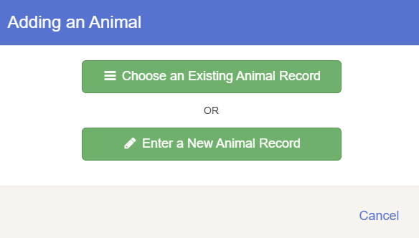-Select **Enter a New Animal Record**, pick the appropriate Animal Type from the dropdown menu, and enter the required info.

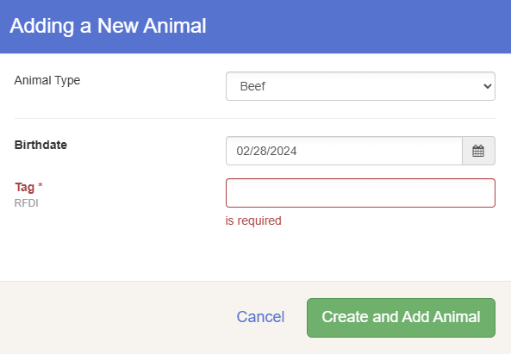RFDI Tag is issued at the mandatory Attica Fair ear tagging dates

-Click **Create and Add Animal**. If everything looks good click **Continue**

-answer any questions specific to that animal type- click Continue

* Remember to enter showmanship classes! Click **Add another Entry**

Is this kids or adult sizes?

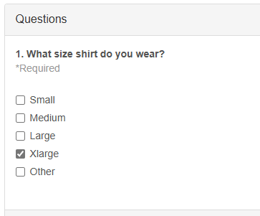

 8. Complete any items that need your attention. Blue Box.



* If an entry “needs your attention” you can move on and work on other entries. The system automatically saves. You can come back later to complete.
* Entries cannot move to completion and be submitted until all required fields are filled in.

 9. At this point you can either:

  A) Add another entry for this exhibitor

  B) Click Exhibitors to begin entries for another family member

  C) Register another exhibitor (FFA families)

  D) Continue to payment- ***Only if all entries for your family are complete***.

* There will be no payment due.
* Click through all screens and click Submit. Entries are not complete until you submit