ATTICA FAIR 2024
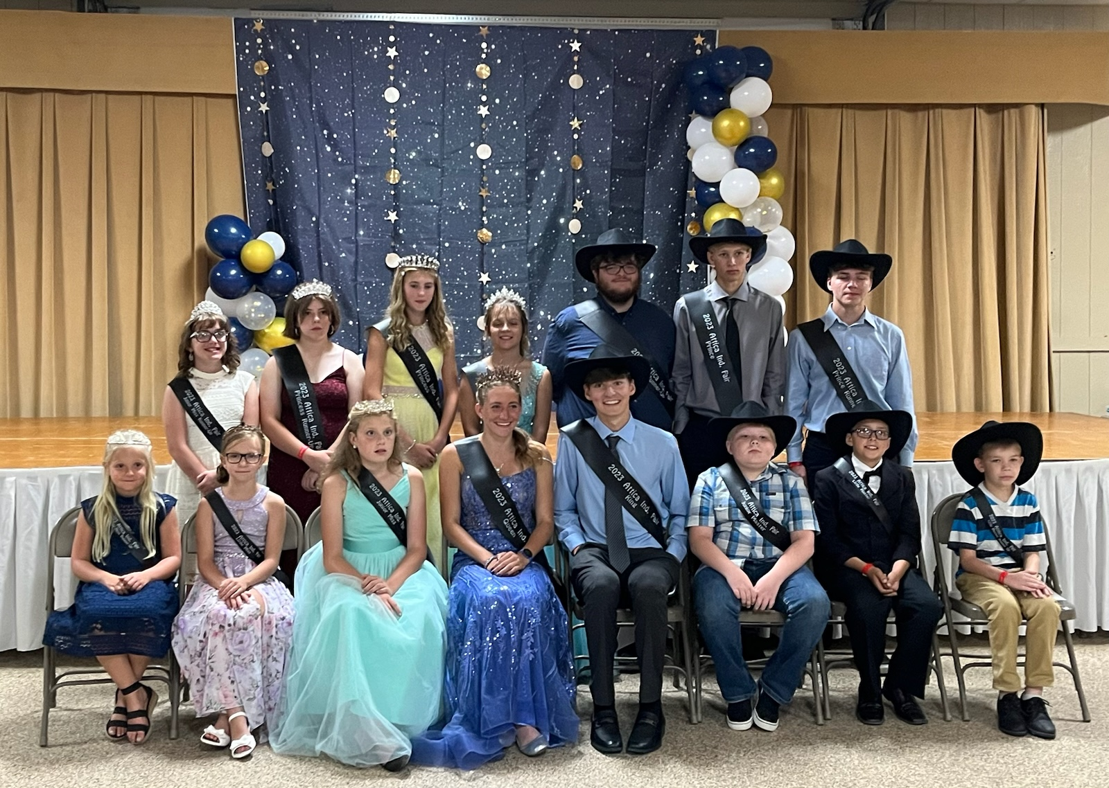
ROYALTY CONTEST
Tuesday, August 13th 2024
5:00 P.M. in the Social Hall

Open to 2024 Attica Independent Fair Exhibitors and/or Seneca East Students.
    - Age limits as of January 1, 2024 are as follows:
King/Queen 16-19 years Prince/Princess 13-15 years
Junior Miss/Junior Master 9-12 years Little Miss/Little Master 5-8 years
    - Entries may be picked up by contact Jaime Martin, or at www.atticafair.com.
    - All entries must be returned to: Jaime Martin, 921 North State Route 18 Republic, OH 44867, no later than July 15, 2024.
    - Once a contestant has won a title at the Attica Independent Fair, they are not eligible to compete in that tile category again.
    - The places awarded will be as follows: Queen & King, and Runner Up,
Princess & Prince, and Runner Up, Junior Miss & Master, and Runner Up
Little Miss & Master, and Runner Up
6. The mandatory preliminary interview will be held on Tuesday, August 13, 2024 starting at 10 am
the Attica Fairground.
7. The final portion of the contest will be held on Tuesday, August 13, 2024at 5:00pm in the Entertainment Building.
The following are mandatory rules for the conduct and dress of all Royalty:
Dress code for Royalty during the Fair:
  - Formal the night of the contest.
  - Dress pants/shorts or Dresses in the evening (after 5:00pm)
  - Nice jeans, dress pants, dress shorts or dresses during the day.
  - NO GRAPHIC T-SHIRTS
  - Sashes and crowns must be worn during the fair unless cleaning pens, washing animals or showing animals or 4-H projects.
  - Crown is only to be worn if presented the night of the contest.
  - NO sashes or crowns in the show arena or at auction
Conduct and participation during the fair.
- All royalty will present themselves in a mannerly fashion. Any questions or concerns should be directed to Jaime Martin, if needed a Senior Fair board member will be available also.
- Required to help with various fair activities, including but not limited to: handing out awards, being introduced during grandstand events, helping where needed.
- Royalty is required to participate in no less than seven parades or functions outside of the Attica Independent Fair.
- All royalty will continue to represent the Attica Independent Fair until their replacements are crowned the following year.
Dress and Attendance for Parades/Visiting Royalty/Other Events
- Dress according to type of parade or Fair, per Queen/Jaime.
- If you are attending a Parade which requires a float you will need to help with set up and tear down.
- If a float is being used, all Royalty should ride on the float, if possible
- You may attend any event regardless to other Royalty participation. However, share your participation with the Queen and Royalty Coordinator so that all other royalty can participate as well if they would like.
- The Royalty Court is asked to help with decorating the stage/hall for next year’s pageant.
Visiting or Other Events
- As visiting royalty (on Stage), you must dress appropriate for the scheduled event per the Queen and/or Jaime Martin.
- A small introduction for on-stage will be written and approved
Queens Participation
- Inviting Royalty for the following year.
- Emcee following year’s Contest
- Contacting other royalty court, as to parades and functions.
- Set-up the Fair Booth for reigning year.
- Stay in contact with Jaime during the reigning year to help plan plan for incoming court.
- The Queen is strongly recommended to compete in the Ohio State Fair’s Queen Contest in January, 2025 at the Ohio Fair Manager’s Association Convention.

