**ATTICA FAIR ROYALTY CONTEST**

**Tuesday, August 8th 2023 @ 6:00 P.M. in the Social Hall**

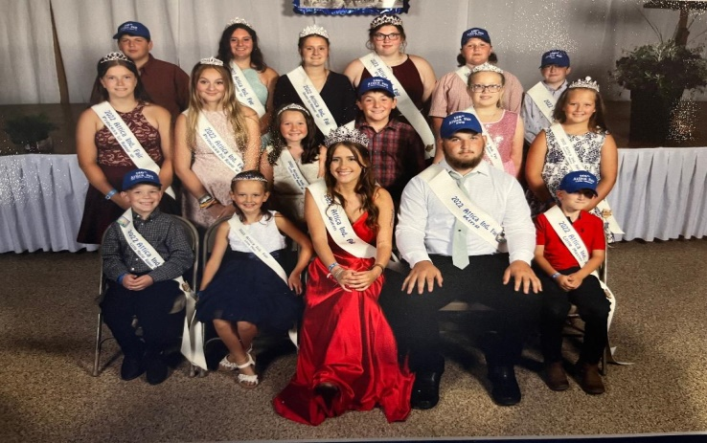

* + 1. Open to 2023 Attica Independent Fair Exhibitors and/or young men and women in the Seneca East School District.
    2. Age limits as of January 1, 2023 are as follows:

**King/Queen 16-19 years Prince/Princess 13-15 years Junior Miss/Junior Master 9-12 years Little Miss/Little Master 5-8 years**

* + 1. Entries may be picked up at Seneca East Public Library, Making Waves, or at www.atticafair.com.
    2. All entries must be returned to: Jaime Martin, 921 North State Route 18 Republic, OH 44867 or emailed to ejhmartin@yahoo.com no later than **July 25, 2023**.
    3. Once a contestant has won a title at the Attica Independent Fair, they are not eligible to compete in that contest again.
    4. The places awarded will be as follows: **Queen & Runner Up King & Runner Up** **Princess & Runner Up Prince & Runner Up** **Junior Miss & Runner Up** **Junior Master & Runner Up Little Miss & Runner Up Little Master & Runner Up**

7. The mandatory preliminary interview will be held on Tuesday, August 8, 2023 starting at 12pm the Attica Fairground.

8. The final portion of the contest will be held on **Tuesday,** August 8, 2023 in the Entertainment Building at the Fairgrounds. The Junior Miss/Junior Master and Little Miss/Little Master portion will begin at 6:00P.M. with the Princess/Prince and Queen/King Contest to follow.

The following are mandatory rules for the conduct and dress of all Royalty.

Dress code for Royalty during the Fair.

* 1. Formal the night of the contest.
  2. Dress pants or Dresses in the evening (after 5:00pm)
  3. Nice jeans, dress pants, dress shorts or dresses during the day.
  4. **NO T-SHIRTS**
  5. Sashes and crowns must be worn during the fair unless cleaning pens, washing animals or showing animals or 4-H projects.
  6. Crown is only to be worn if presented the night of the contest.
  7. NO sashes or crowns in the show arena or at auction

**Conduct and participation during the fair.**

1. All royalty will present themselves in a mannerly fashion. Any questions or concerns should be directed to Jaime Martin, if needed a Senior Fair board member will be available also.
2. Required to help with various fair activities.
3. Royalty is required to participate in no less than seven parades or functions outside of the Attica Independent Fair.
4. All royalty will continue to represent the Attica Independent Fair until their replacements are crowned the following year.

**Dress and Attendance for Parades**

1. Dress according to type of parade or Fair, per Queen/Jaime.
2. If you are attending a Parade which requires a float you will need to help with set up and tear down.
3. If a float is being used, all Royalty should ride on the float, if possible
4. You may attend any event regardless to other Royalty participation. However, share your participation with the Queen and Royalty Coordinator so that all other royalty can participate as well if they would like.
5. The Royalty Court is asked to help with decorating the stage/hall for next year’s pageant.

**Visiting or Other Events**

1. As visiting royalty (on Stage), you must dress appropriate for the scheduled event per the Queen and/or Jaime Martin.
2. A small introduction for on-stage will be written and approved

**Queens Participation**

1. Inviting Royalty for the following year.
2. Emcee next year’s Contest
3. Contacting other royalty as to parades and functions.
4. Set-up the Fair Booth for her year.
5. The Queen is strongly recommended to compete in the Ohio State Fair’s Queen Contest in January 2023 at the Ohio Fair Manager’s Association Convention.